***PROJECT : LIBRARY MANAGEMENT SYSTEM***

1. **BRANCH TABLE:**

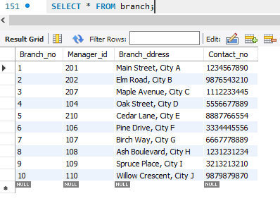

1. **Employee Table:**

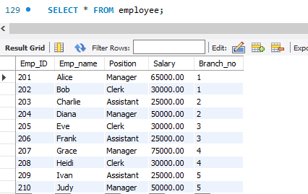

1. **Books Table:**

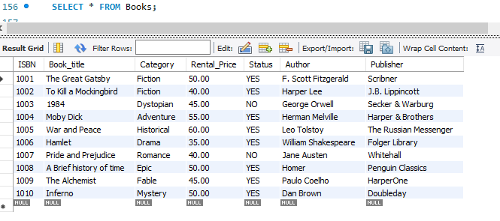

1. **Customer Table :**

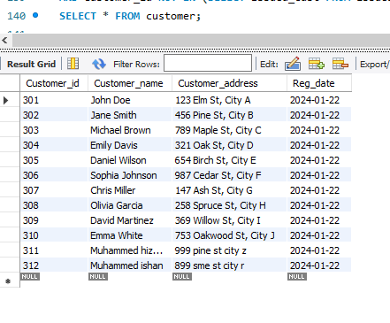

1. **IssueStatus Table:**

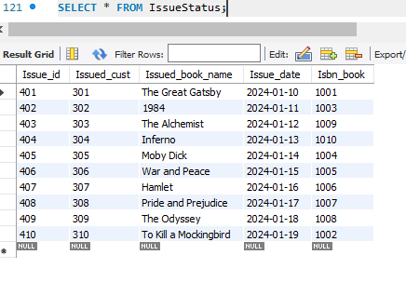

1. **ReturnStatus Table:**

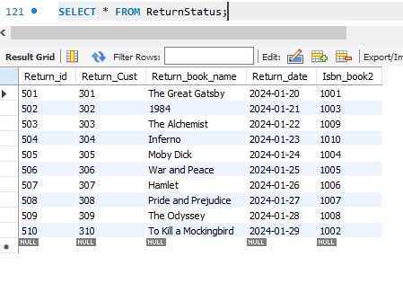

1. Retrieve the book title,category and rental price of all available books.

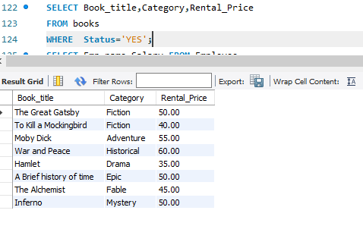

1. List the employee names and their respective salaries in descending order of salary.

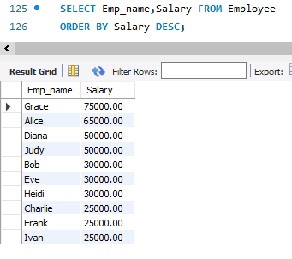

1. Retrieve the book titles and the corresponding customers who have issued those books.

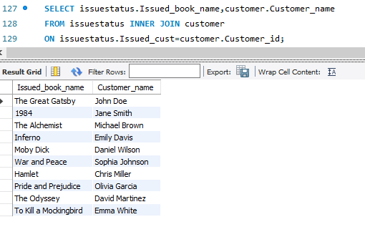

1. Display the total count of books in each category.

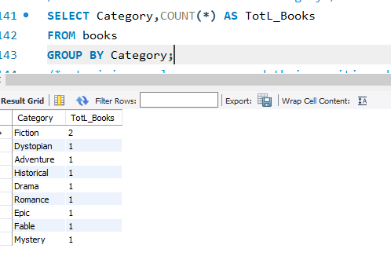

1. Retrieve the employee names and their positions for the employees whose salaries are above RS 50000.

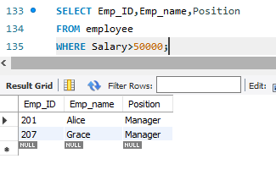.

1. List the customer names who registered before 2024-01-30 and have not issue any books yet List the customer names who registered before 2024-01-30 and have not issue any books yet

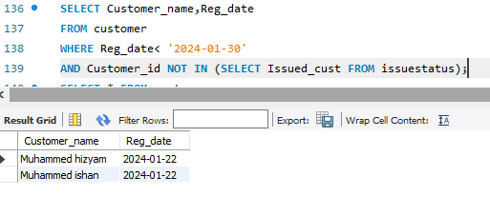

1. Display the branch numbers and total count of employees in each branch.

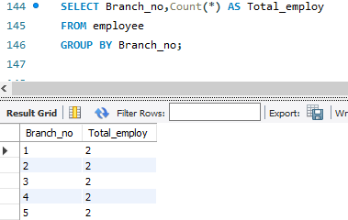

1. Display the names of customers who have issued books in the month of January 2024.

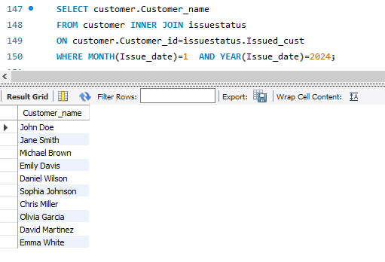

1. Retrieve book_title from book table containing history .

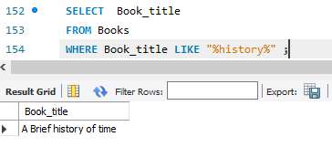

1. Retrieve the branch numbers along with the count of employees for branches having more than 5 employees.

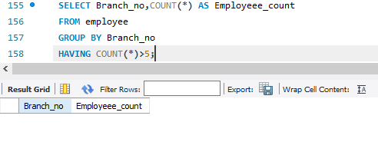

Note : There is no branch numbers having greater than 5 employees.

1. Retrieve the name of employees who manages branches and their respective branch addresses.

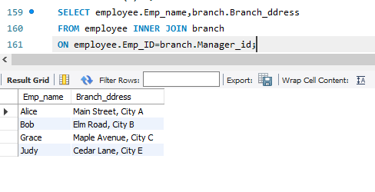

1. Display the names of customers who have issued books with a rental price higher than Rs 25.

